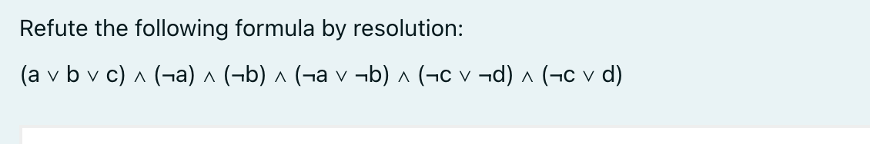

We can separate the formula by splitting the formula into parts and combining them:

1. (a \vee b \vee c) \wedge (\neg a) which leads to (b \vee c)
2. The previous clause, (b \vee c), combined with \wedge (\neg b), leads to (c)
3. The two clauses \wedge (\neg c \vee \neg d) \wedge (\neg c \vee d) leads to (\neg c)
4. Combining the results of point 2, (c), and 3, (\neg c), it leads to an empty clause

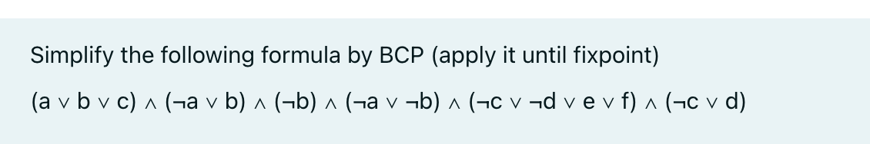

Since there is (\neg b), the formula will be simplified by applying BCP with (\neg b).

In (a \vee b \vee c), considering b false, it becomes (a \vee false \vee c), which leads to (a \vee c).

In (\neg a \vee b) since b is false, it becomes (\neg a \vee false), which leads to (\neg a).

In (\neg a \vee \neg b) since b is false, it becomes (\neg a \vee true) which is always true and can be ignored.

Other parts are not affected by b.

The remaining formula is (a \vee c) \wedge (\neg a) \wedge (\neg b) \wedge (\neg c \vee \neg d \vee e \vee f) \wedge (\neg c \vee d).

This time, the formula will be simplified using (\neg a).

In (a \vee c) since a is false, it becomes (false \vee c), which leads to c.

Other partes are not affected by a.

The remaining formula is (c) \wedge (\neg a) \wedge (\neg b) \wedge (\neg c \vee \neg d \vee e \vee f) \wedge (\neg c \vee d).

This time, the formula will be simplified using c that have to be true.

In (\neg c \vee \neg d \vee e \vee f) since c is true, it leads to (\neg d \vee e \vee f).

In (\neg c \vee d) since c is true, it becomes (false \vee d) which leads to d.

Other parts are not affected by c.

The remaining formula is (c) \wedge (\neg a) \wedge (\neg b) \wedge ( \neg d \vee e \vee f) \wedge (d).

Now the formula will be simplified by d.

In (\neg d \vee e \vee f) since d is true, it becomes (false \vee e \vee f), which leads to (e \vee f).

Other parts are not affected by d.

The remaining formula is (c) \wedge (\neg a) \wedge (\neg b) \wedge ( e \vee f) \wedge (d).

No more unit clauses can be derived, therefore it is a fixpoint.

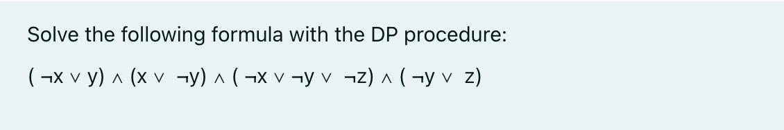

Starting with the formula (\neg x \vee y) \;\wedge\; (x \vee \neg y) \;\wedge\; (\neg x \vee \neg y \vee \neg z) \;\wedge\; (\neg y \vee z).

Eliminating x by resolution.

Clauses containing x:

(x \vee \neg y).

Clauses containing (\neg x):

(\neg x \vee y), \quad (\neg x \vee \neg y \vee \neg z).

Other clauses:

(\neg y \vee z).

Solving on x.

(x \vee \neg y) \quad\text{and}\quad (\neg x \vee y) yield (\neg y \vee y), which is a tautology (ignored).

(x \vee \neg y) \quad\text{and}\quad (\neg x \vee \neg y \vee \neg z) yield (\neg y \vee \neg y \vee \neg z), which simplifies to (\neg y \vee \neg z). Keeping this clause.

Removing all old clauses with x or (\neg x), formula left with (\neg y \vee z) \;\wedge\; (\neg y \vee \neg z).

Eliminating y.

Formula only has clauses with (\neg y), so there is no clause containing y to resolve with. The formula remains

(\neg y \vee z) \;\wedge\; (\neg y \vee \neg z).

This is satisfiable if y is false, because then both clauses are automatically true and z can be either true or false. If y were true, we would need both z and (\neg z).

From the original clauses

(\neg x \vee y) \quad\text{and}\quad (x \vee \neg y),

substitute y = False. Then

(\neg x \vee false), becomes (\neg x), so x must also be false.

The final result is:

x= False, y=False, z can be either true or false